AWS Notes

Share Responsibility
Customer Is Responsible For Security In The Cloud
- Customer data
- Platform, applications, identity & access management
- Operating system, network & firewall configuration
- Client-side data encryption & data integrity authentication
- Server-side encryption: file system and/or data
- Networking traffic protection: encryption, integrity, identity
AWS Is Responsible For Security Of The Cloud
- Software
  - Compute
  - Storage
  - Database
  - Networking
- Hardware / AWS Global Infrastructure
  - Regions
  - Availability Zones
  - Edge Locations
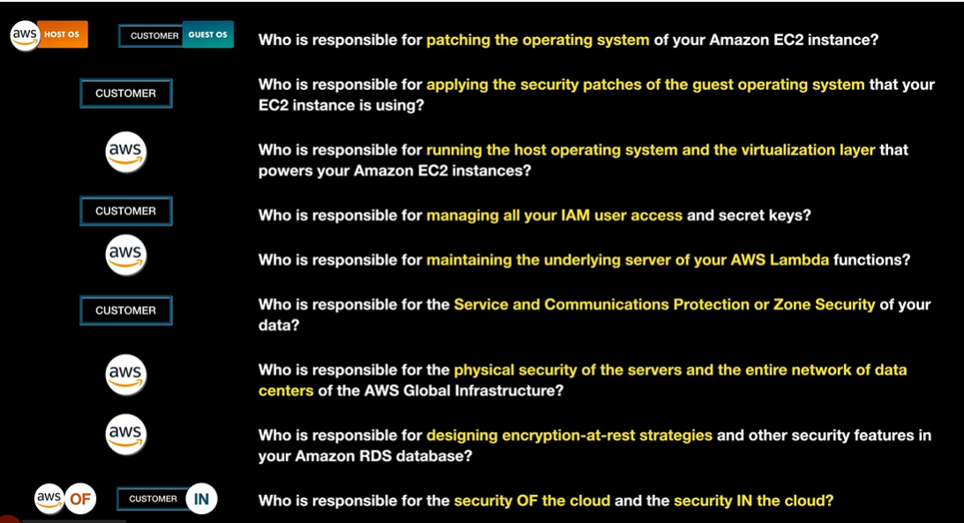

EC2 Types

EC2 type | Definition | When you might use it
On-Demand | Pay for compute by the second or hour with no long-term commitment. | Short-term workloads, unpredictable traffic, testing, development, or when you need flexibility.
Reserved Instances | Commit to a specific instance configuration for 1 or 3 years in exchange for a discount. | Steady, predictable workloads like production web servers, databases, or apps that run continuously.
Spot Instances | Use unused EC2 capacity at a steep discount, but AWS can interrupt the instance when capacity is needed back. | Fault-tolerant, flexible workloads like batch jobs, data processing, CI/CD runners, rendering, or stateless workers.
Dedicated Instances / Dedicated Hosts | Run EC2 instances on hardware dedicated to your AWS account. Dedicated Hosts give more control over the physical server and licensing. | Compliance, regulatory isolation, or bring-your-own-license scenarios such as Windows Server, SQL Server, or Oracle licensing.

AWS Compute Services
Category | Service | What it is | Possible scenario where you might use it
Virtual Machines | Amazon EC2 | Core AWS virtual machine service. You choose instance type, OS, storage, networking, scaling, and security settings. | Hosting a production web application where you need full control over the server, OS patches, installed software, networking, and scaling rules.
Virtual Machines | Amazon Lightsail | Simplified virtual private server service with bundled compute, storage, networking, and predictable pricing. Easier than EC2, but less flexible. | Running a small WordPress site, simple business website, test server, or lightweight application without managing complex AWS infrastructure.
Virtual Machines | AWS Outposts | AWS-managed hardware installed in your own data center or physical location. It lets you run AWS services on-premises. | A hospital, factory, or financial company needs low-latency local processing or must keep some workloads on-site for compliance, while still using AWS tools.
Serverless | AWS Lambda | Runs code without managing servers. You upload a function, and AWS runs it in response to events. You pay only when it runs. | Automatically resize an image after it is uploaded to S3, process messages from a queue, run backend logic for an API, or trigger automation after a CloudWatch event.
Orchestration / Platform | AWS Elastic Beanstalk | Platform-as-a-service for deploying applications. You upload code, and Beanstalk provisions EC2, load balancers, scaling, monitoring, and deployment settings. | A development team wants to deploy a web app quickly without manually configuring EC2 instances, Auto Scaling groups, and load balancers.
Orchestration / Batch Processing | AWS Batch | Runs large-scale batch jobs by provisioning and managing compute resources automatically. Good for jobs that start, process, and finish. | Running thousands of data-processing jobs, scientific simulations, financial risk calculations, video encoding tasks, or scheduled ETL workloads.
Containers | Amazon ECS | AWS-native container orchestration service. Runs Docker containers on EC2 instances or serverless with Fargate. Simpler AWS-integrated alternative to Kubernetes. | Running a containerized microservices app where you want tight integration with AWS services and less Kubernetes management overhead.
Containers | Amazon EKS | Managed Kubernetes service on AWS. AWS manages the Kubernetes control plane, while you run container workloads using Kubernetes tools and APIs. | A company already uses Kubernetes and wants to move workloads to AWS while keeping Kubernetes manifests, Helm charts, and existing DevOps workflows.
Containers / Serverless Compute | AWS Fargate | Serverless compute engine for containers. Works with ECS and EKS. You run containers without managing EC2 instances. | Running containers without worrying about server patching, cluster capacity, or EC2 instance sizing. Useful for APIs, background workers, and microservices with variable demand.

Storage Services
AWS Storage Services
Service | What it is | Possible scenario where you might use it
EC2 Instance Store | Temporary or Ephemeral block storage physically attached to some EC2 host machines. It is very fast, but data is lost if the instance stops, terminates, or the underlying hardware fails. | Use for temporary data such as caches, buffers, scratch files, high-speed processing space, or data that can be recreated.  Works kind of like ram, once shutdown it loses the data. When EC2 terminates data is lost.
Amazon EBS | Elastic Block Store provides persistent block storage volumes for EC2 instances. It behaves like a virtual hard drive attached to an EC2 instance. | Use for EC2 boot volumes, application data, databases, or workloads that need durable storage attached to a single instance.  In same AZ as EC2, can be encrypted using KMS  SSD – fast, frequent r/w, IOPS (input output operations person second)  HDD – slower, data archive or backups (Mbps)  4 TYPES  General Purpose SSD (attached to 1 EC2)  Provisioned IPOS SSD (can be attached to multiple Nitro-base EC2 Instance) no concurrent file modification, would need EFS for that)  Throughput Optimized HDD (attached to 1 EC2)  Cold HDD(attached to 1 EC2)
Amazon S3 | Scalable object storage for files, backups, logs, static website assets, images, videos, and data lakes. Data is stored as objects in buckets. | Use for storing application files, backups, static websites, analytics data, media, logs, or shared durable storage accessed over HTTP/API.
Amazon S3 Glacier | Low-cost archival storage classes within S3 for rarely accessed data. Retrieval can take minutes to hours depending on the Glacier class. | Use for compliance archives, old backups, historical records, audit logs, or data that must be retained but is rarely accessed.  S3 Standard – frequently accessed  S3 Intelligent-Tiering (unknown access patter)  S3 Standard-IA (long lived less frequently accessed)  S3 One Zone-IA (long lived less frequently accessed)  S3 Glacier – low cost long term storage  S3 Glacier Deep Archive
Amazon EFS | Elastic File System provides managed, scalable shared file storage using NFS. Multiple EC2 instances can access the same file system at the same time. | Use for shared web content, Linux home directories, content management systems, shared application files, or workloads needing multi-instance file access.
Amazon FSx for Lustre | High-performance managed file system optimized for compute-intensive workloads. It integrates with S3 and is designed for very fast file processing. | Use for machine learning, high-performance computing, financial modeling, video rendering, genomics, or workloads needing high throughput and low latency.
Amazon FSx for Windows File Server | Managed Windows file storage built on Microsoft Windows Server and SMB protocol. Supports Active Directory integration. | Use for Windows applications, shared department drives, user home directories, SQL Server file shares, or lift-and-shift Windows workloads.
AWS Backup | Centralized backup service for AWS resources. It can manage backup policies, schedules, retention, and restores across services. | Use to automate backups for EBS, EFS, FSx, RDS, DynamoDB, and other supported AWS services with centralized compliance and retention policies.
AWS Storage Gateway | Hybrid cloud storage service that connects on-premises environments to AWS storage. Provides file, volume, and tape gateway options. | Use when an on-premises data center needs access to cloud-backed storage, cloud backups, disaster recovery, or gradual migration to AWS.

S3 Types
S3 storage class | What it is | Possible scenario where you might use it
S3 Standard | General-purpose S3 storage for frequently accessed data. It provides high durability, high availability, and low-latency access. | Use for active application files, websites, mobile app content, frequently accessed images, videos, logs, or data lakes.
S3 Intelligent-Tiering | Automatically moves objects between access tiers based on usage patterns. Good when you do not know how often data will be accessed. | Use for unpredictable workloads, changing access patterns, user uploads, analytics data, or data that may be hot now but cold later.
S3 Standard-IA | Infrequent Access storage for long-lived data that is accessed less often but still needs quick retrieval when needed. Lower storage cost than Standard, but retrieval has a fee. | Use for backups, disaster recovery files, older reports, archived project files, or data accessed monthly or occasionally.
S3 One Zone-IA | Infrequent Access storage kept in a single Availability Zone instead of multiple AZs. Lower cost than Standard-IA, but less resilient if that AZ is lost. | Use for replaceable infrequently accessed data, secondary backups, recreated reports, thumbnails, or replicated data that does not need multi-AZ resilience.
S3 Glacier Instant Retrieval | Archive storage for rarely accessed data that still needs millisecond retrieval. Lower storage cost than Standard-IA, with retrieval charges. | Use for medical images, compliance documents, media archives, or old records that are rarely accessed but must be available immediately.
S3 Glacier Flexible Retrieval | Low-cost archival storage for long-term data. Retrieval can take minutes to hours depending on the retrieval option. Previously called S3 Glacier. | Use for long-term backups, audit logs, compliance records, or archives where retrieval speed is not urgent.
S3 Glacier Deep Archive | Lowest-cost S3 storage class for rarely accessed long-term retention. Retrieval usually takes hours. | Use for data kept for years, legal archives, regulatory retention, historical records, old backups, or data that almost never needs to be restored.

Lifecycle Policy – can move files to lower cost S3 over time…. 30, 90 180 days…
Access Control List (ACL) secure access to S3 and objects
Bucket Policy – control external access so s3
S3 Versioning and MFA prevent accidental deletion in S3
Cross Region Replication (CRR) – replicate across AWS regions, for backup purposes
Transfer Acceleration, Multipart Upload – speed up or expedite data transfer (update/download) of S3 objects
S3 Glacier vs S3 Glacier Deep Archive
Comparison point | S3 Glacier | S3 Glacier Deep Archive
Cost | Low | Lowest
Minimum storage duration | 90 days | 180 days
Data deleted after 1 day / 24 hours | You will be billed for the entire 90 days | You will be billed for the entire 180 days
Data deleted after 90 days | Normal storage usage charge | You will be billed for the entire 180 days
Data deleted after 180 days | Normal storage usage charge | Normal storage usage charge
Expedited retrieval | 1 - 5 minutes | Not available
Standard retrieval | 3 - 5 hours | Within 12 hours
Bulk retrieval | 5 - 12 hours | Within 48 hours

EFS

Amazon Elastic File System (Amazon EFS)
Feature | Description
Service type | Scalable shared file storage service
File system standard | Provides a POSIX-compliant shared file system
Access model | Can be simultaneously accessed by multiple Amazon Linux EC2 instances in different Availability Zones
Protocol | Uses the Network File System (NFS) protocol
Works as | A shared file system / file share
OS support | Supports Linux workloads. For Windows file shares, use Amazon FSx for Windows File Server instead.
Storage class: EFS Standard | Standard EFS storage class for frequently accessed files
Storage class: EFS Infrequent Access | Lower-cost EFS storage class for files that are accessed less often
Lifecycle policy | Can move files from EFS Standard to EFS Infrequent Access after 30 days

Amazon FSx for Windows File Server
Feature | Description
Service | Amazon FSx for Windows File Server
Service type | Fully managed Microsoft Windows file server service
Protocol | Uses the Server Message Block (SMB) protocol
Directory integration | Can integrate with Microsoft Active Directory
AWS managed directory option | Can integrate with AWS Managed Microsoft AD
Shared file storage use | Can be used as shared file storage
Example workload: SharePoint | Can provide shared file storage for Microsoft SharePoint
Example workload: SQL Server | Can provide shared file storage for Microsoft SQL Server
Example workload: Microsoft containers | Can provide shared file storage for Microsoft container workloads

AWS Backup
Feature | Description
Service type | Fully managed backup service
Main purpose | Automates server and database backup processes
Service-level backups | Supports backups for Amazon FSx, Amazon EFS, Amazon DynamoDB, and Amazon EC2
Service-level snapshots | Supports snapshots for Amazon Aurora, Amazon RDS, Amazon EBS, and AWS Storage Gateway
Default retention shown | 7 days
Maximum short-term retention shown | 35 days
Longer retention shown | 90 days, one year, or even more

AWS Storage Gateway
Feature | Description
Service | AWS Storage Gateway
Service type | Hybrid cloud storage service
Main purpose | Connects on-premises applications and data storage to the AWS Cloud
How it works | Integrates local and cloud storage systems by using a gateway
On-premises connection | Connects an on-premises data center and on-premises applications to AWS storage
Deployment option shown | Can run as a virtual machine
Hardware option shown | Can use a physical AWS Storage Gateway appliance
Migration note | If the goal is to move or migrate storage from on-premises to AWS, AWS DataSync is usually the better service to use.

Gateway type | What it does | Protocol / access | AWS storage used | Common use case
File Gateway | Stores and retrieves objects in Amazon S3 | Uses NFS and SMB protocols | Amazon S3 | On-premises file-based applications that need cloud-backed object storage
Volume Gateway | Provides block storage to on-premises applications with low latency | Uses iSCSI | Amazon S3 and Amazon EBS snapshots | On-premises apps that need block storage with cloud-backed snapshots
Tape Gateway | Cloud-based Virtual Tape Library | On-premises apps connect as iSCSI devices | Amazon S3, S3 Glacier, and S3 Glacier Deep Archive | Replace physical tape backup infrastructure

